Table/Ticket Purchasing Step-by-Step

- Go to landing page: https://www.silentauctionpro.com/onlineticketpurchase.php?groupId=3668
- Choose if you would like to purchase a table or ticket and choose the quantity you would like.
  - If choosing a table, you can leave the ticket slots blank if you do not yet have confirmed guests.
- You will be taken to this screen.
  - If you have an account, please login
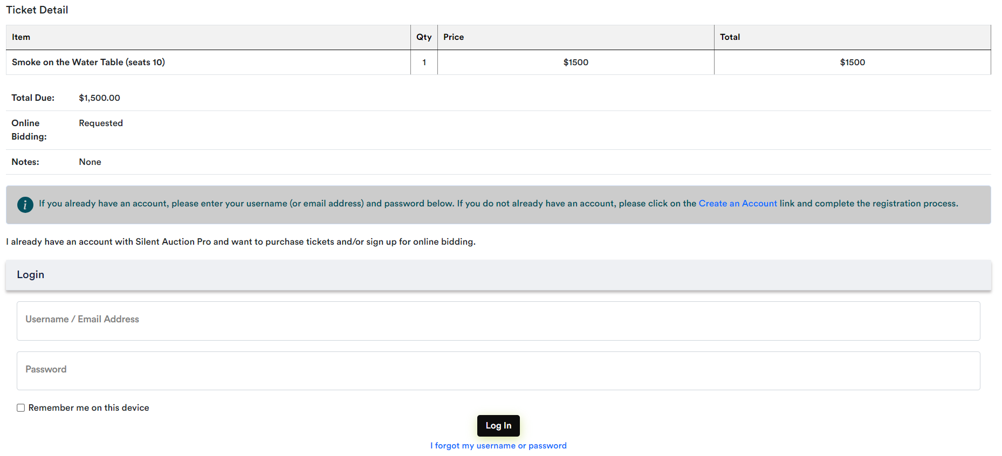
  - If you do not have an account, you will need to create one to proceed
- Creating an account
  - Fill in the required information below
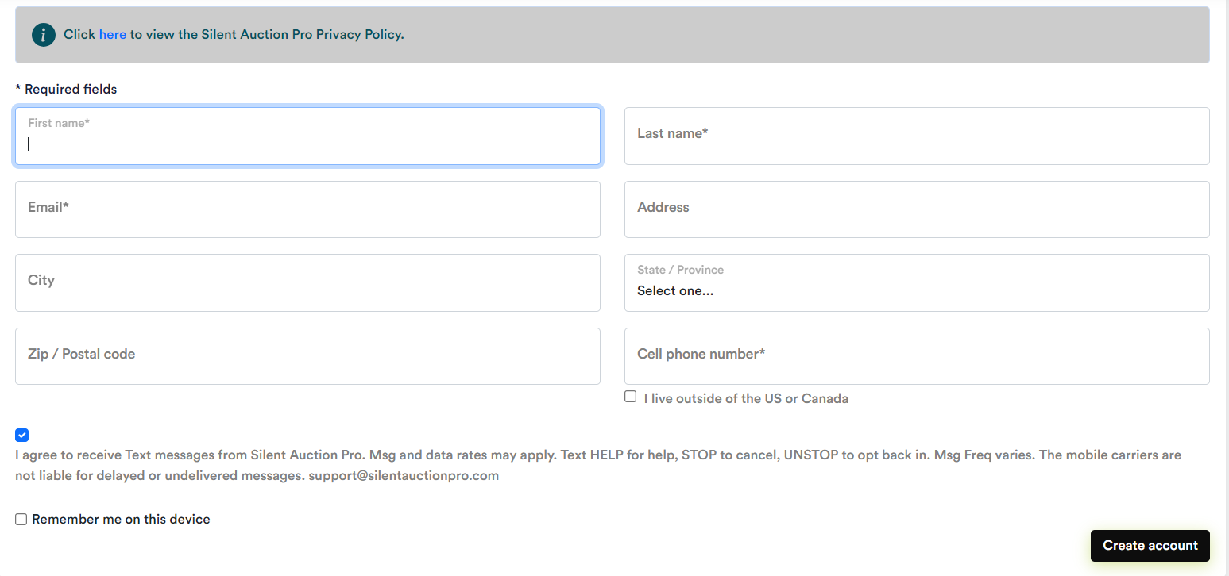
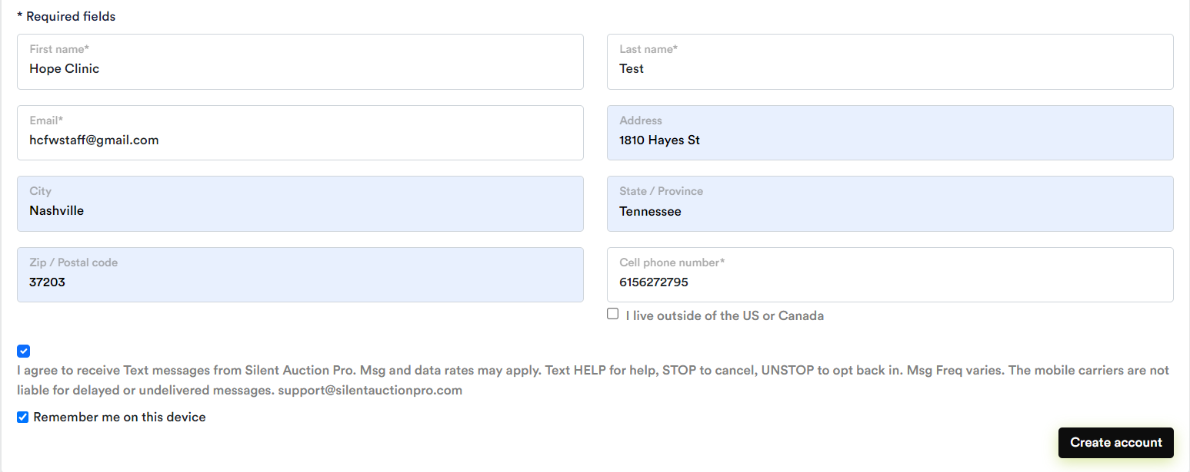
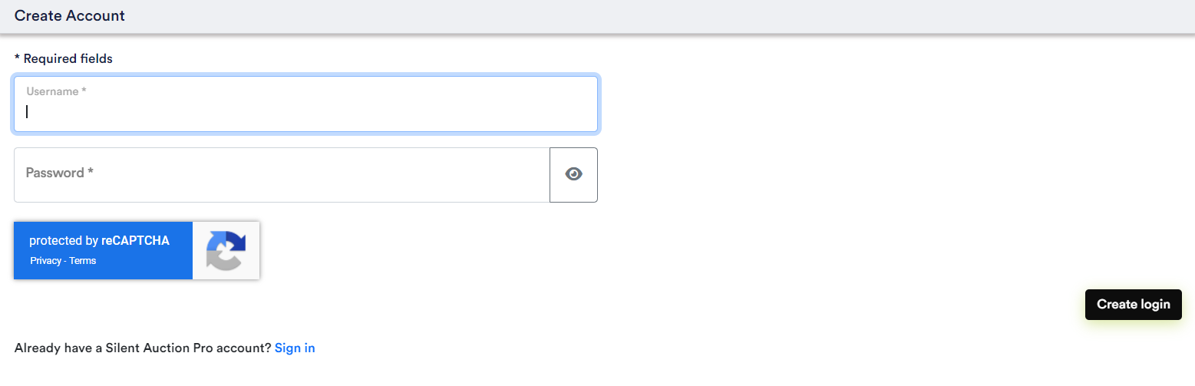
- After you create your login, you will be taken back to this screen
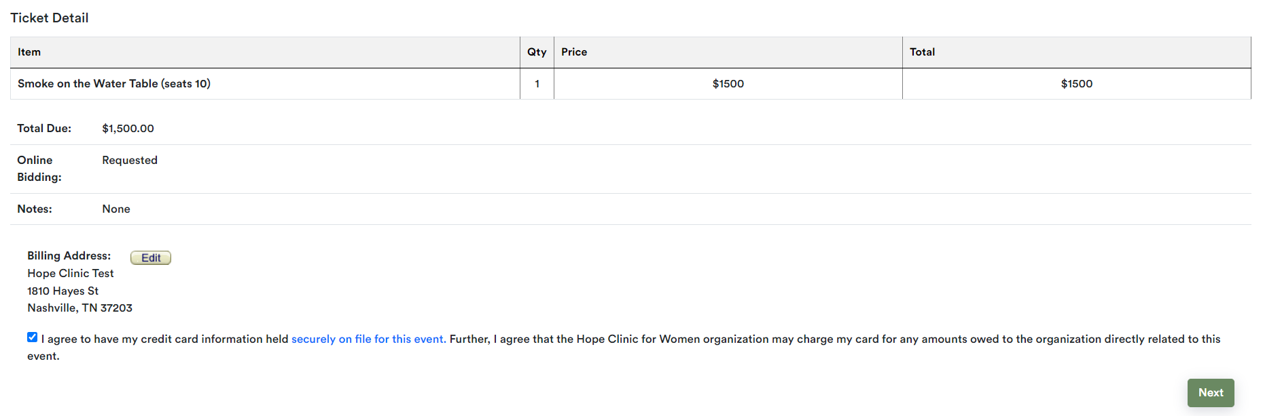
  - Please check the “I agree” checkbox to proceed.
  - Although a credit card is stored to ensure that Hope Clinic is protected – we can use other forms of payment for any auction items.
- You will then be asked to enter credit card your information
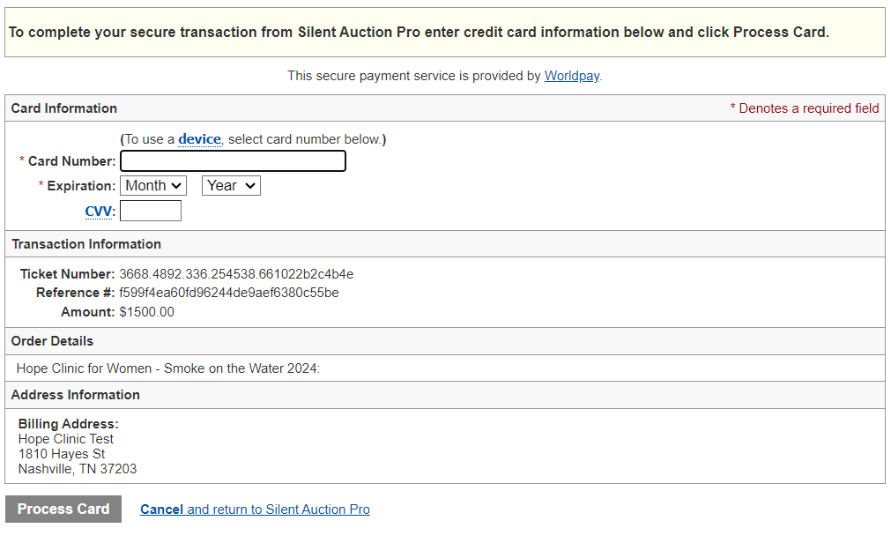

Entering your Guests for Your Table
- You will automatically be the first guest.
- The other 9 spots are open for your guests – boxes open asking for their information.
- If you know your guests, please put their names and email addresses, so they are able to claim their tickets to the event.
- If you do not know your guests, that is okay! You can still purchase your table. When you know your guests, you can login to your account, and the system will automatically prompt you to fill in your guest list.

